

FACULTY OF INFORMATION AND COMMUNICATION TECHNOLOGY

DCOMP204 – WEB DESIGN 1

Title : Individual Assignment 2
Issue Date : Week 4
Due Date : Week 9
Lecturer/Examiner : Cornelious M Grant
Name of Student/s : Michelle Nyakeh Kamanda
Student ID No. : 905005508
Class : BIT 1102F
Year/Semester : 2/1

Academic Honesty Policy Statement

I/We, hereby attest those contents of this attachment are my own work. Referenced works, articles, art, programs, papers or parts thereof are acknowledged at the end of this paper. This includes data excerpted from CD-ROMs, the Internet, other private networks, and other people’s disk of the computer system.

Student’s Signature: Date: 30th NOVEMBER 2025
LECTURER’S COMMMENTS/GRADE:

for office use only upon receive
Remark

DATE:
TIME:
RECEIVER’S NAME:

HOME PAGE SCREENSHOT
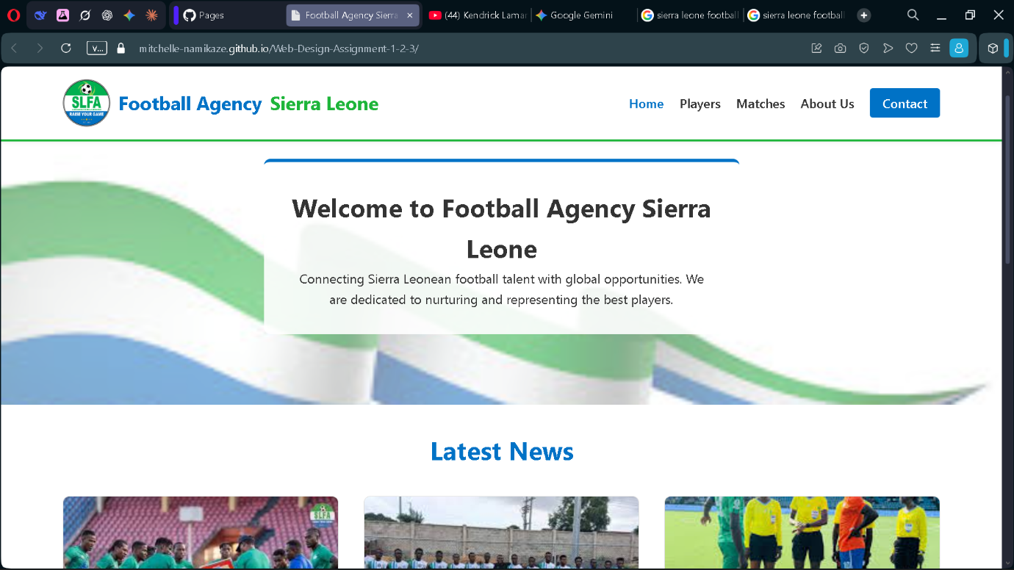

PLAYERS PAGE SCREENSHOT

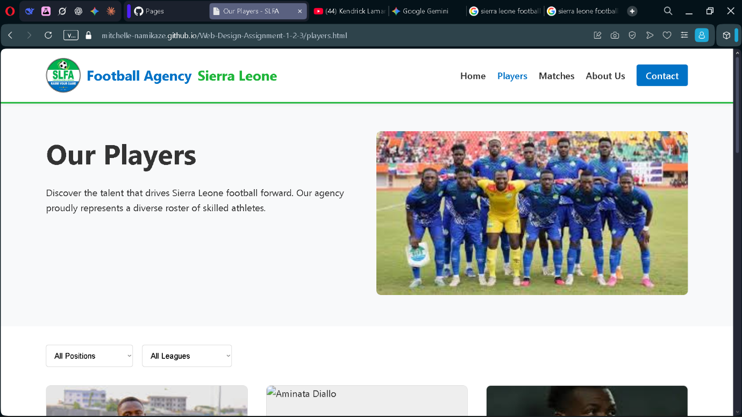

MATCHES PAGE SCREENSHOT
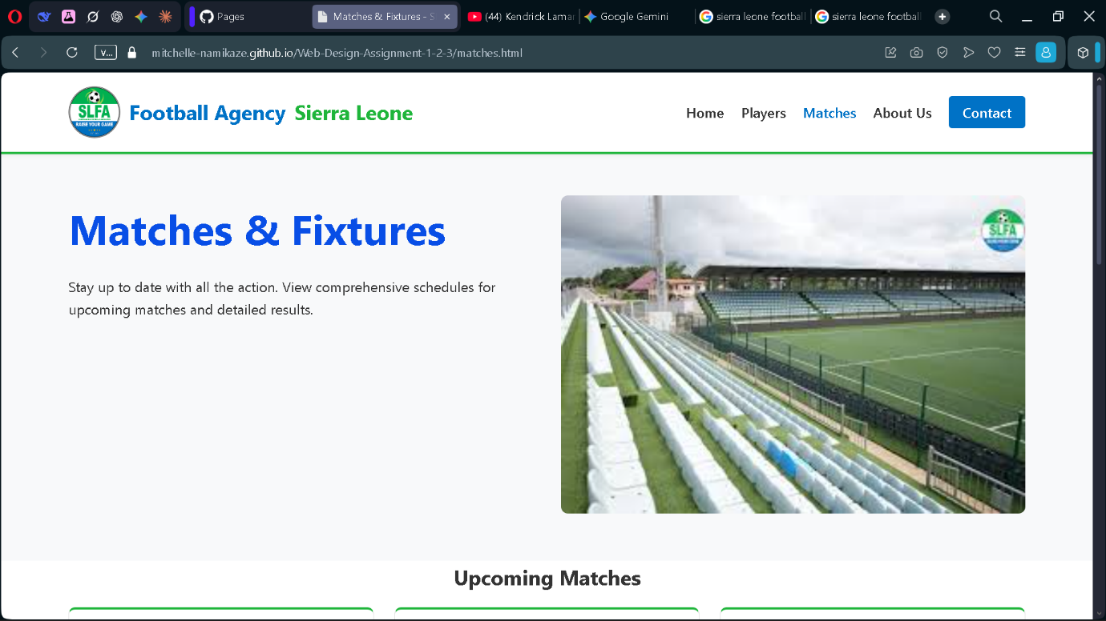

ABOUT US PAGE SCREENSHOT
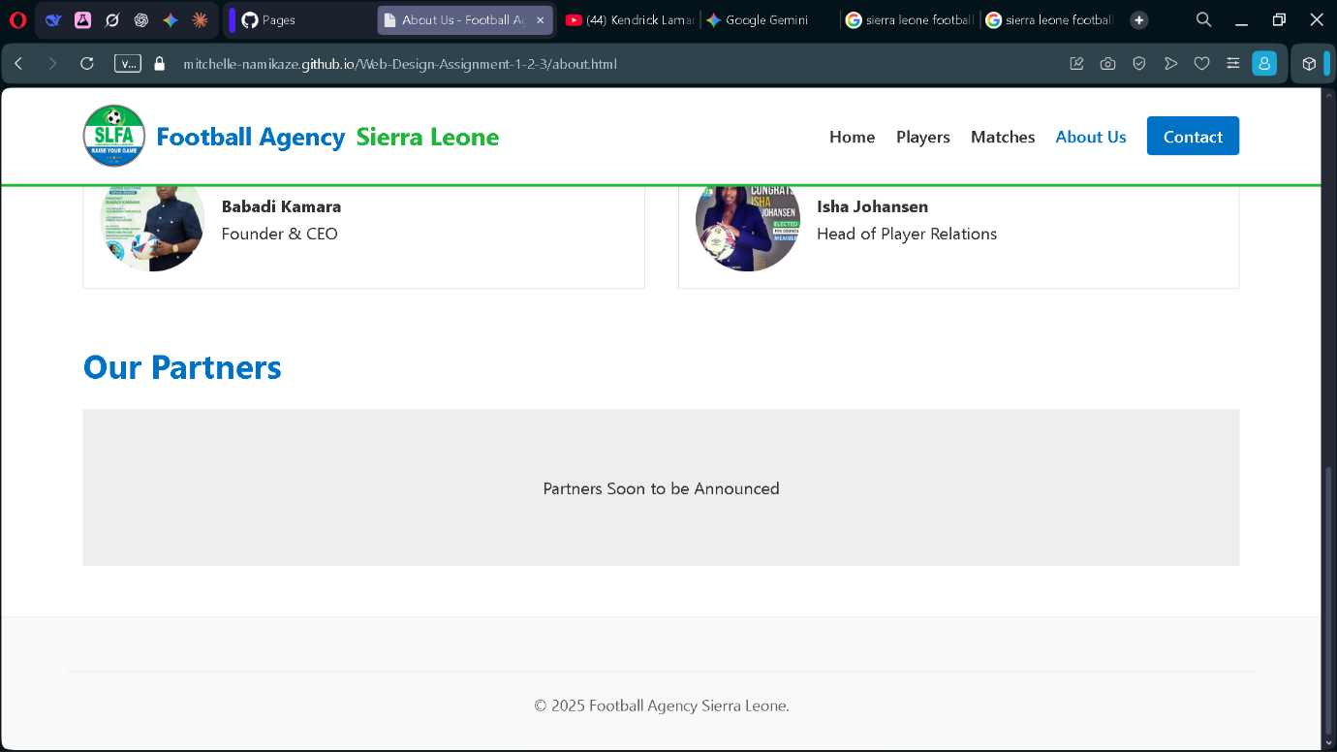

CONTACT US PAGE SCREENSHOT
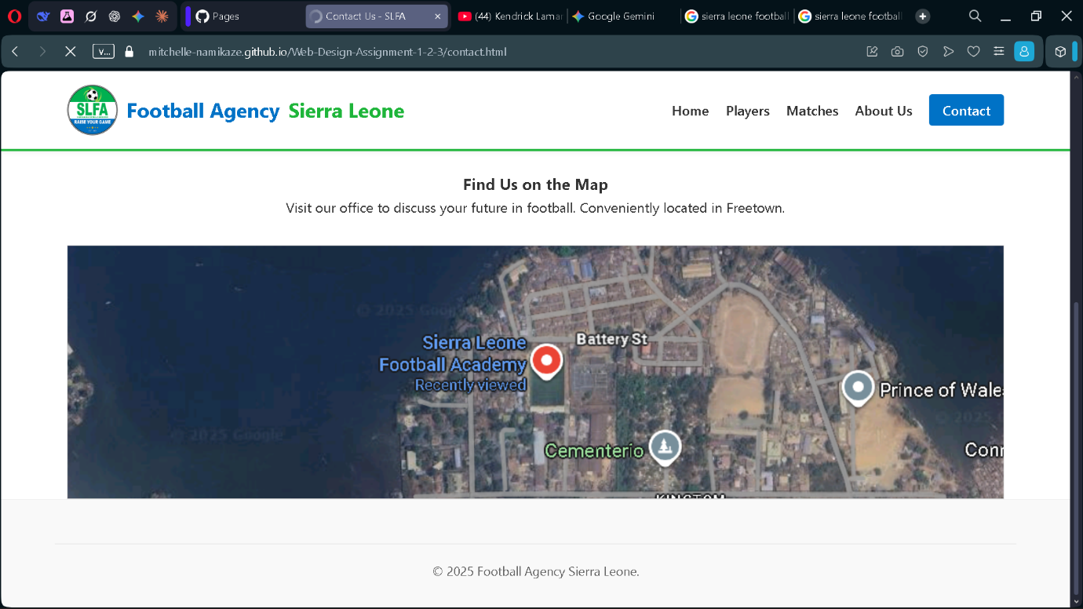

HOME PAGE CODE
<!DOCTYPE html>
<html lang="en">
<head>
<meta charset="UTF-8">
<meta name="viewport" content="width=device-width, initial-scale=1.0">
<title>Football Agency Sierra Leone - Home</title>
<link rel="stylesheet" href="style.css">
</head>
<body>

<header>
<div class="container">
<nav>
<div class="logo">
<img src="logo.png" alt="Logo" style="border-radius: 50%;" width="60" height="60">
Football Agency <span>Sierra Leone</span>
</div>
<ul class="nav-links">
<li><a href="index.html" class="active">Home</a></li>
<li><a href="players.html">Players</a></li>
<li><a href="matches.html">Matches</a></li>
<li><a href="about.html">About Us</a></li>
<li><a href="contact.html" class="btn-nav">Contact</a></li>
</ul>
</nav>
</div>
</header>

<main>
<section class="hero">
<div style="position: absolute; width: 100%; height: 100%; overflow: hidden; z-index: -1;">
<img src="banner.jpg" alt="Hero Background" style="width: 100%; height: 100%; object-fit: cover; opacity: 0.50;">
</div>

<div class="hero-overlay">
<h1>Welcome to Football Agency Sierra Leone</h1>
<p>Connecting Sierra Leonean football talent with global opportunities. We are dedicated to nurturing and representing the best players.</p>
</div>
</section>

<section class="container">
<h2 class="section-title" style="text-align: center;">Latest News</h2>
<div class="grid-3">
<div class="news-card">
<img src="training.jpg" alt="Training" class="img-placeholder" style="height: 200px;">
<div class="card-content">
<h3>Sierra Leonean Talents Shine in European Tryouts</h3>
<p>Our promising young players recently participated in rigorous tryouts across key European clubs, impressing scouts with their skill.</p>
<br>
<a href="#" class="btn">Read More</a>
</div>
</div>
<div class="news-card">
<img src="patnership.jpg" alt="Partnership" class="img-placeholder" style="height: 200px;">
<div class="card-content">
<h3>New Partnership with Local Youth Academy</h3>
<p>Football Agency Sierra Leone is proud to announce a new partnership with the Freetown Youth Football Academy.</p>
<br>
<a href="#" class="btn">Read More</a>
</div>
</div>
<div class="news-card">
<img src="bvf.jpg" alt="League" class="img-placeholder" style="height: 200px;">
<div class="card-content">
<h3>Premier League Season Kickoff</h3>
<p>The new season kicks off this weekend at the National Stadium. See our players in action for Bo Rangers and FC Kallon.</p>
<br>
<a href="#" class="btn">Read More</a>
</div>
</div>
</div>
</section>

<section class="container" style="margin-top: 4rem; margin-bottom: 4rem;">
<h2 class="section-title">Key Highlights & Agency Announcements</h2>
<div style="display: flex; gap: 2rem; flex-wrap: wrap;">
<div style="flex: 1; min-width: 300px;">
<img src="key.jpg" alt="Highlights" class="img-placeholder" style="width: 100%; border-radius: 8px;">
</div>
<div style="flex: 1; min-width: 300px; display: flex; flex-direction: column; justify-content: center;">
<ul style="list-style: none; gap: 1rem; display: flex; flex-direction: column;">
<li style="display: flex; gap: 10px; align-items: flex-start;">
<span style="color: var(--primary-green); font-weight: bold;">✓</span>
Successfully placed 5 players in international leagues this season.
</li>
<li style="display: flex; gap: 10px; align-items: flex-start;">
<span style="color: var(--primary-green); font-weight: bold;">✓</span>
Expanded scouting network to reach remote regions of Sierra Leone.
</li>
<li style="display: flex; gap: 10px; align-items: flex-start;">
<span style="color: var(--primary-green); font-weight: bold;">✓</span>
Hosted a national football summit for talent development.
</li>
</ul>
<div style="margin-top: 2rem;">
<a href="#" class="btn" style="background-color: #333;">View All</a>
</div>
</div>
</div>
</section>

</main>

<footer>
<div class="container">
<div class="footer-content">
<div>
<h4>Football Agency Sierra Leone</h4>
<p>Empowering football talent in Sierra Leone to achieve global success.</p>
</div>
<div>
<h4>Links</h4>
<ul style="list-style: none;">
<li><a href="about.html" style="color: #666;">About Us</a></li>
<li><a href="contact.html" style="color: #666;">Contact</a></li>
</ul>
</div>
<div>
<h4>Contact</h4>
<p>+232 76 123 456</p>
<p>info@fasl.org</p>
<p>Freetown, SL</p>
</div>
</div>
<div class="footer-bottom">
&copy; 2025 Football Agency Sierra Leone. All rights reserved.
</div>
</div>
</footer>

</body>
</html>

